This Document of Understanding outlines the step-by-step procedure for executing the VFP (Vendor Funded Promotions) process in SAP. Each step is accompanied by a placeholder for a screenshot to ensure clarity and ease of execution.
Login To R1E with test user AUTODLL in client 200.
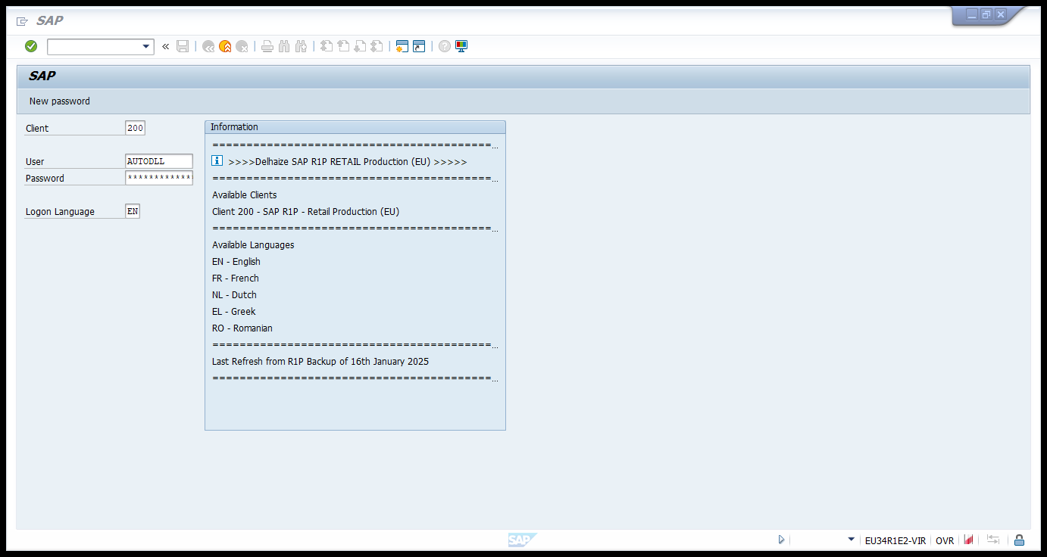

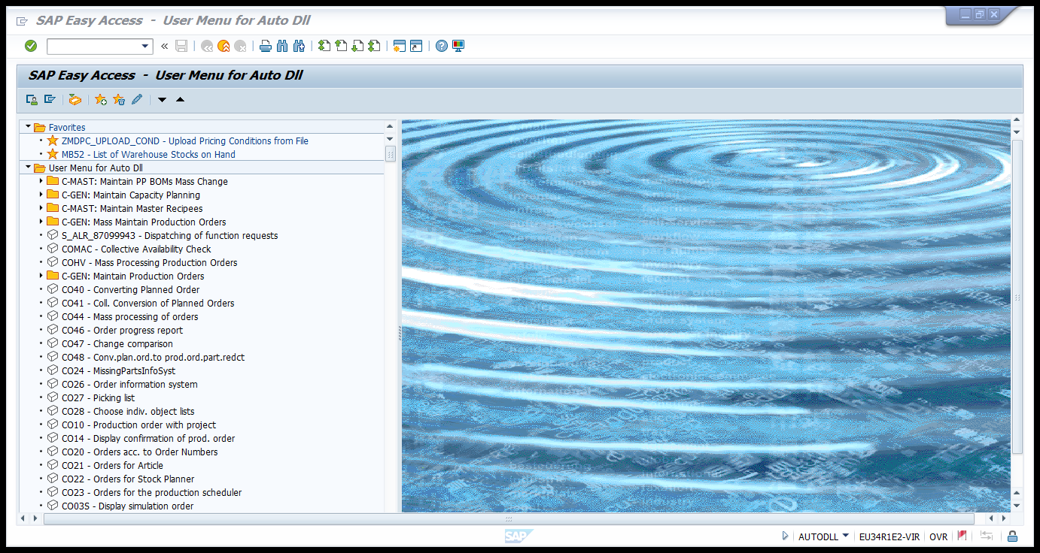

Navigate to the t-code WB2R_SC for the monthly settle of the contract.
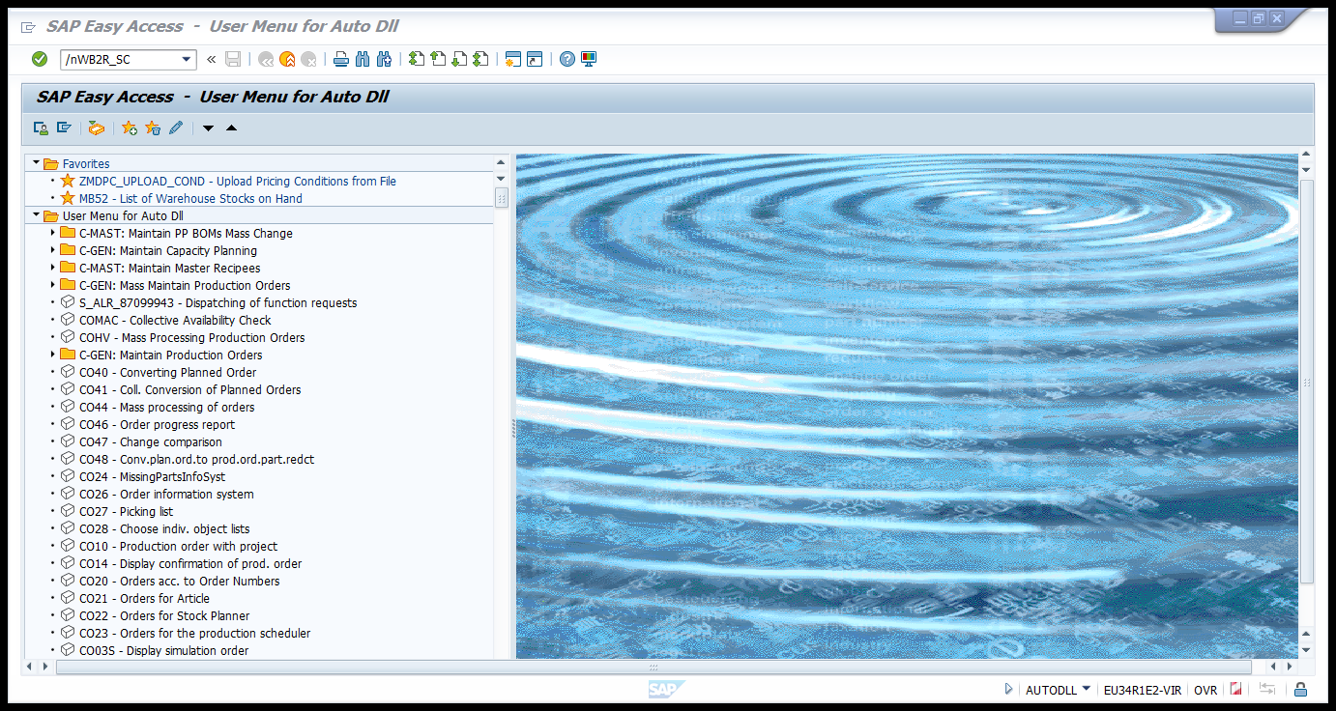

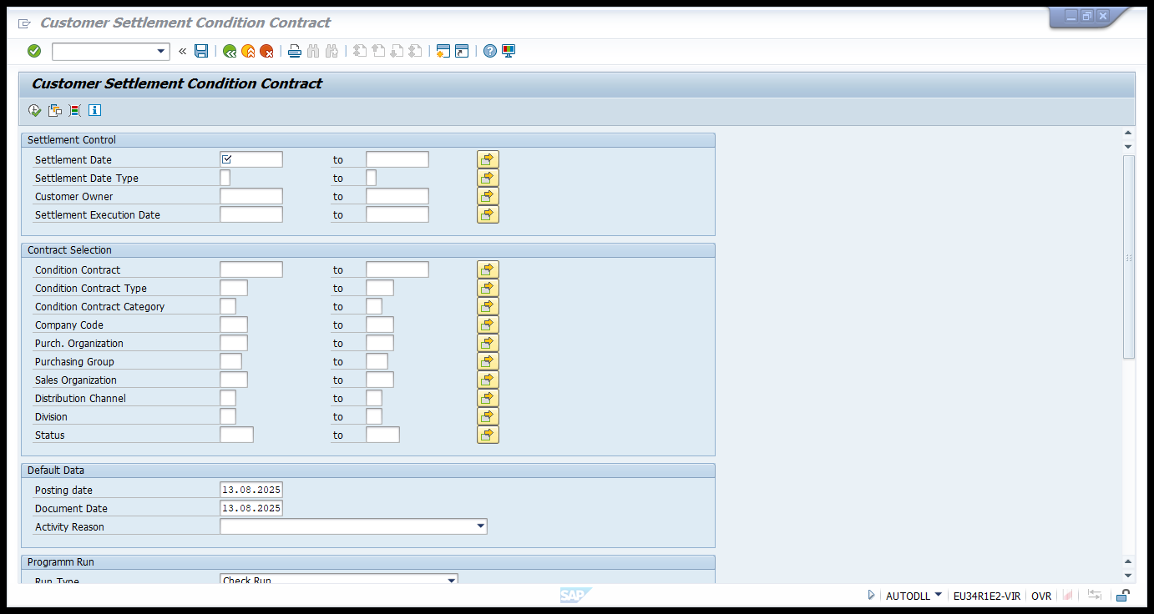

Enter the following details in the following fields:
Settlement date: Last date (31.03.2025) of the month where the settlement is executing.
Condition contract: 350251.
Condition contract type: ZPAF (VFP Affiliates)
Posting date: 445 calendar end date (24.08.2025)
Document Date: Same as settlement date.
Run Type: Live Run
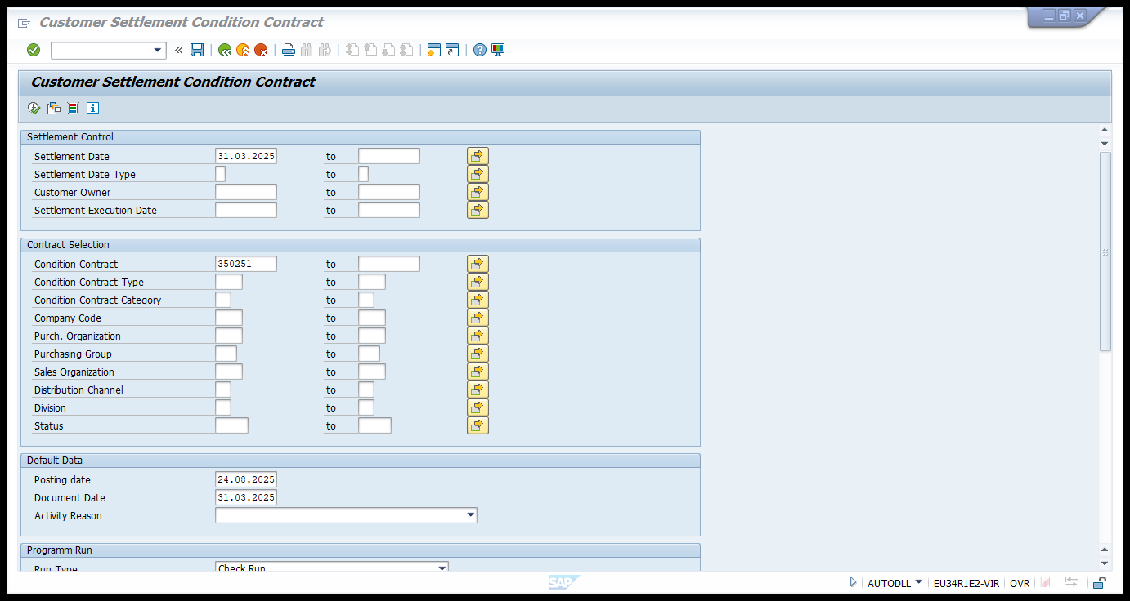

Parallel processing active: Yes (Batch)
Server group Name: BIG_MEM
Maximum of parallel jobs: 25
DB Access interval: 5

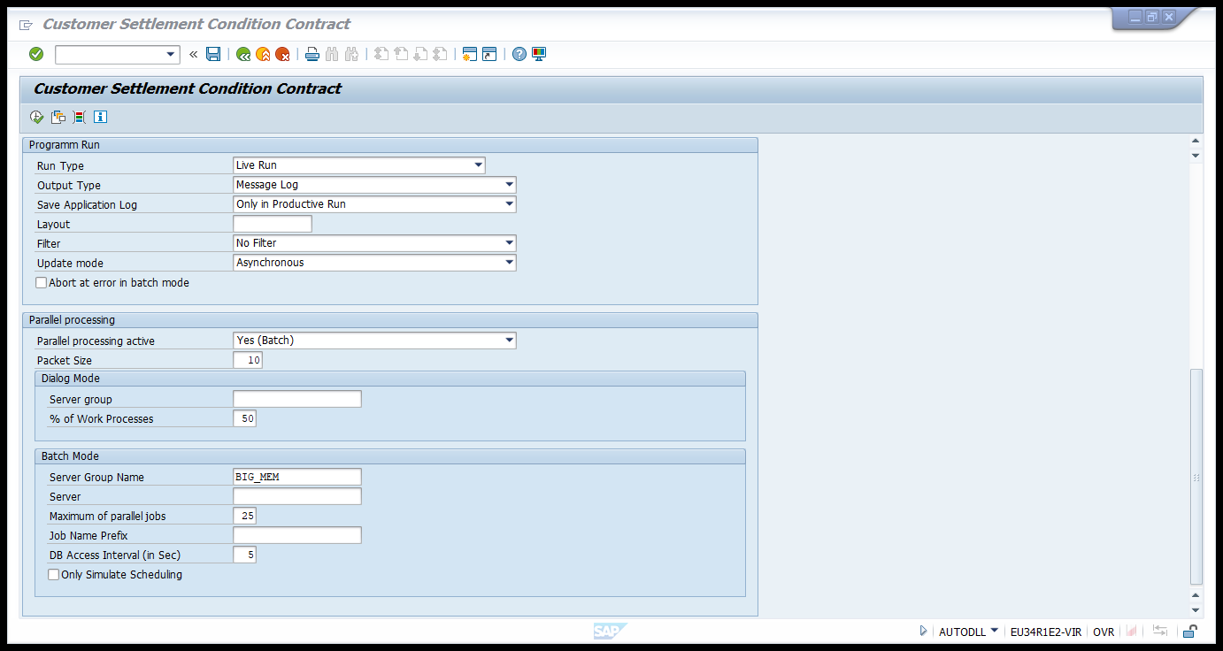
After entering all the details, navigate to Program Execute in Background.
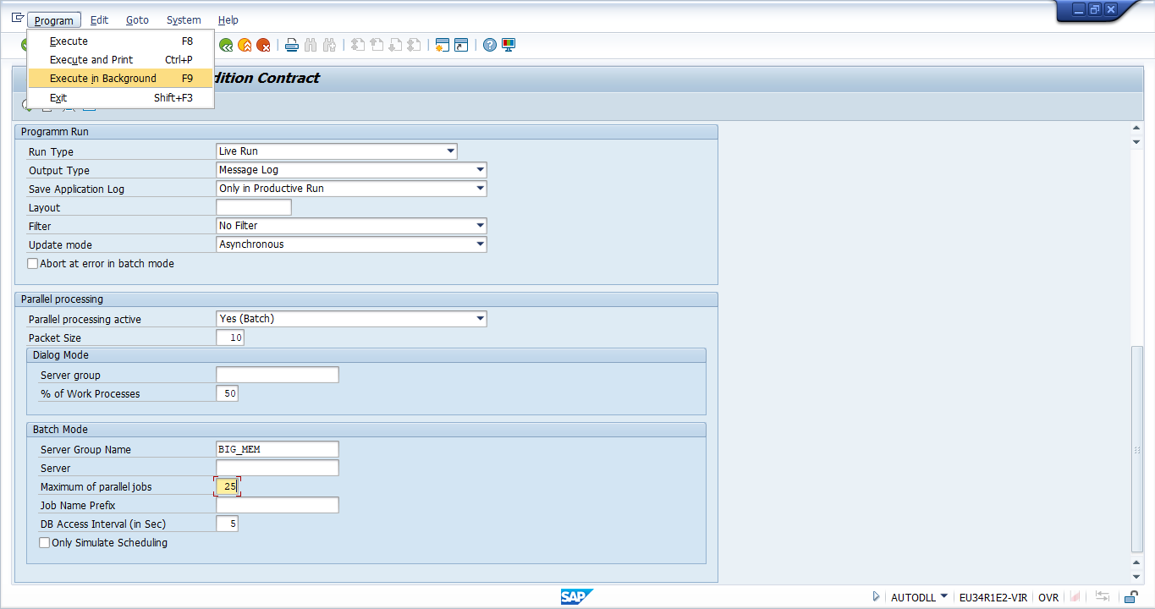

Update the Output device to: LOCL and press on continue Button.
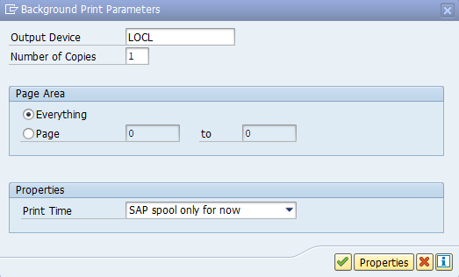

Click on Immediate in below pop up and save.
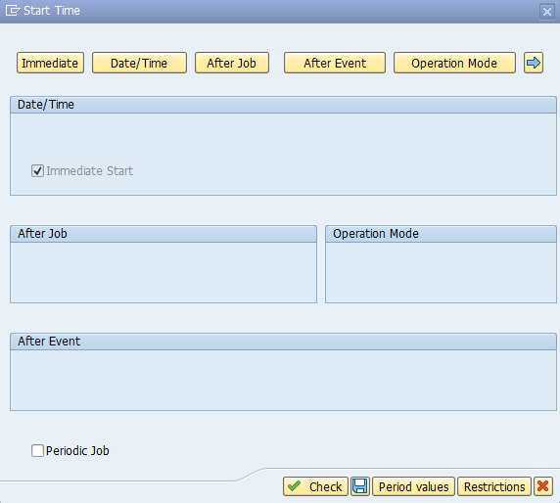
A background process started executing.
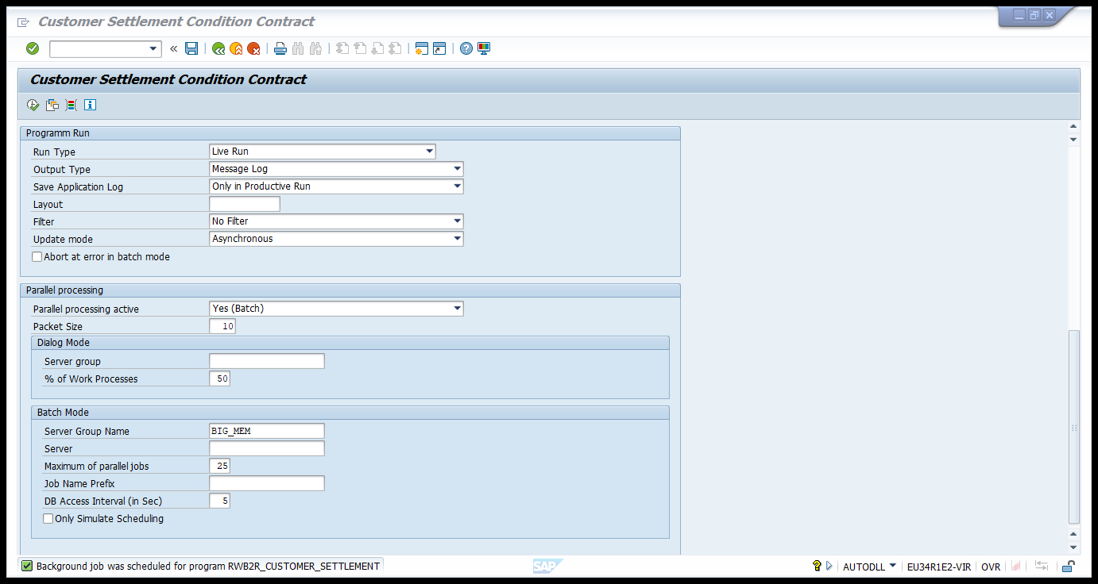

Once the Program started executing in background Navigate to t-code SMX to verify the status of execution. (in this case it’s taken ~23 minutes to complete the execution)
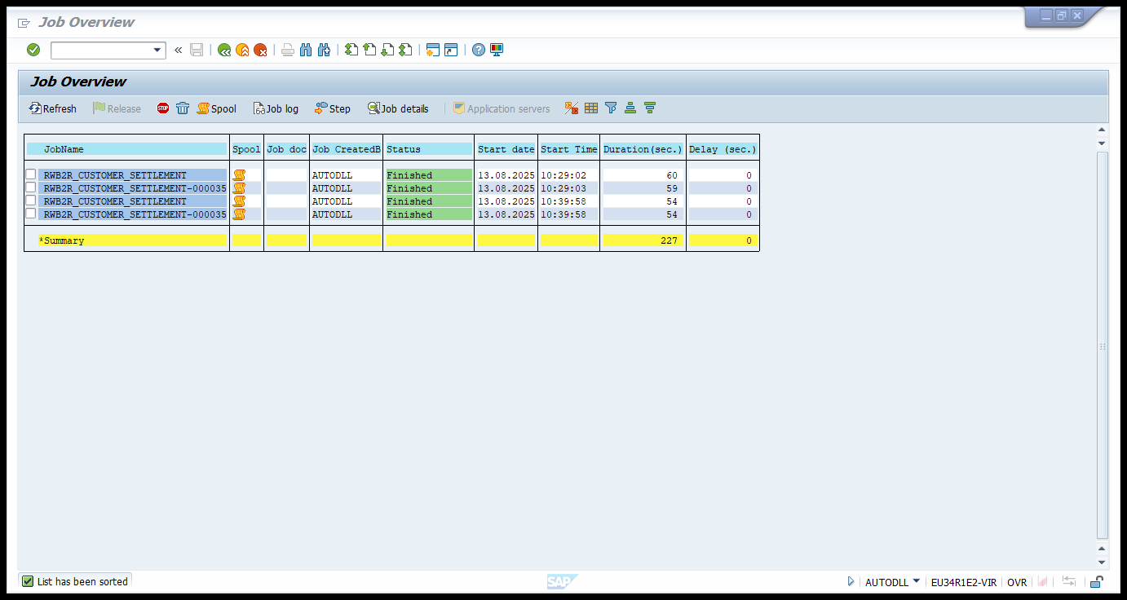

Once the job status is displayed as Finished in t-code SMX Navigate to t-code SLG1 and update the below details.
User: AUTODLL
Program: RWB2R_CUSTOMER_SETTLEMENT
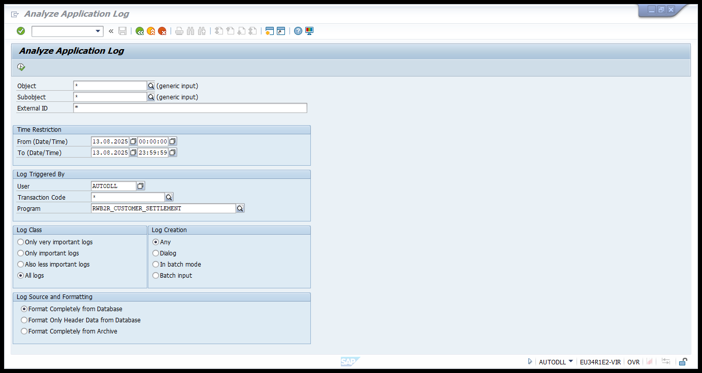

And click on execute button., The Completed job details will be displayed below in green color.
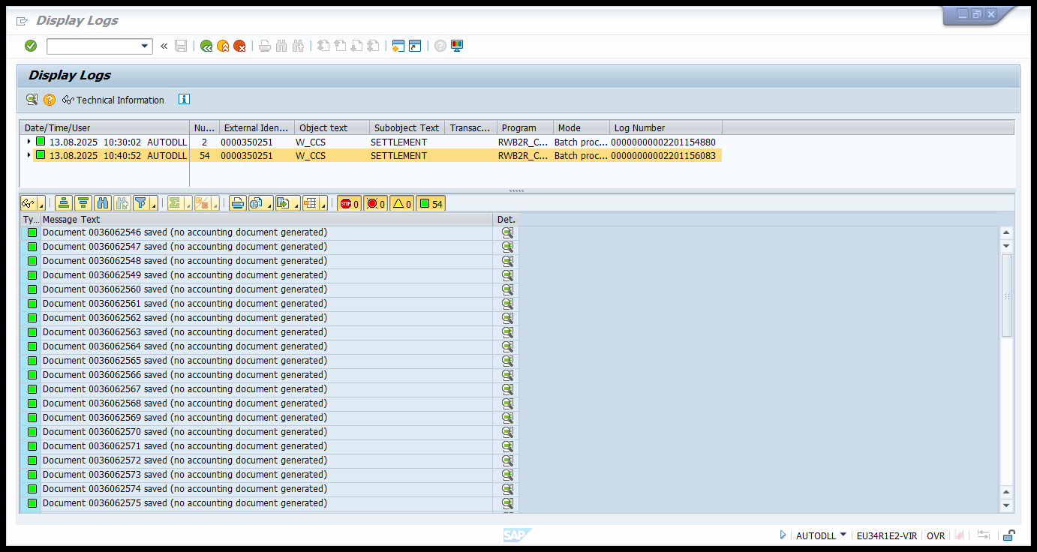
Navigate WLI2 to get the payment document details.
Enter the following details:
Document Date: Same as settlement date (31.03.2025)
Created By: AUTODLL
Created On: 13.08.2025(Execution date)
Posting Status: A
To: B
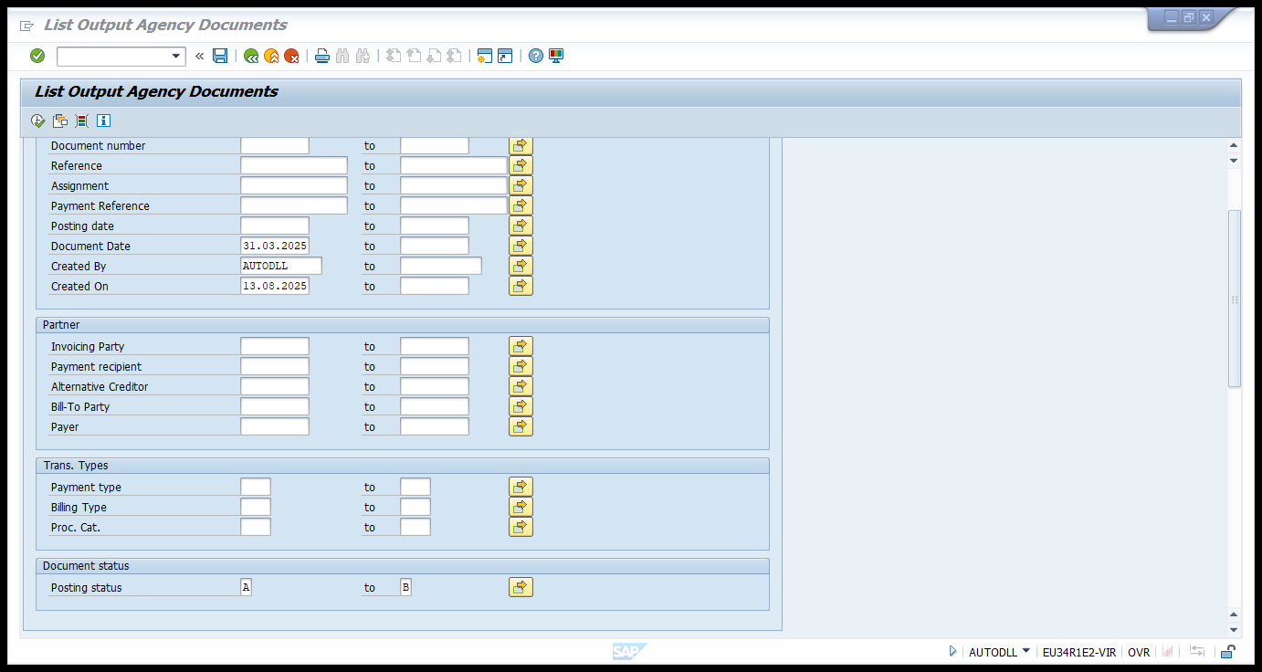

Click On Execute Button
All the payment documents generated will be displayed.
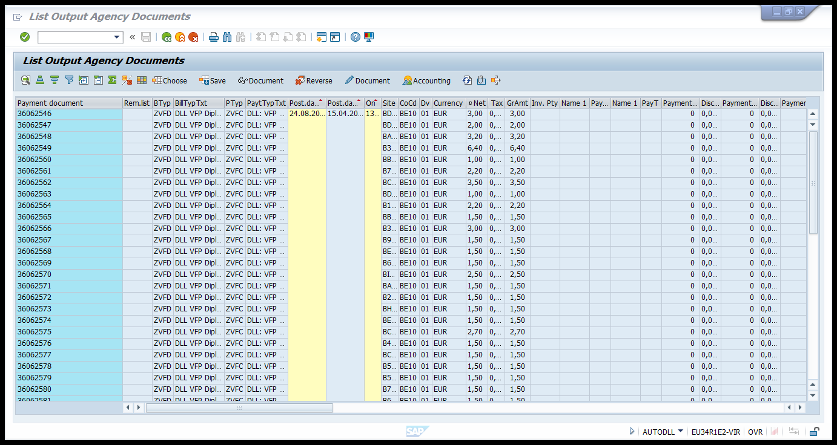

Select the List Export Spreadsheet from Menu bar.
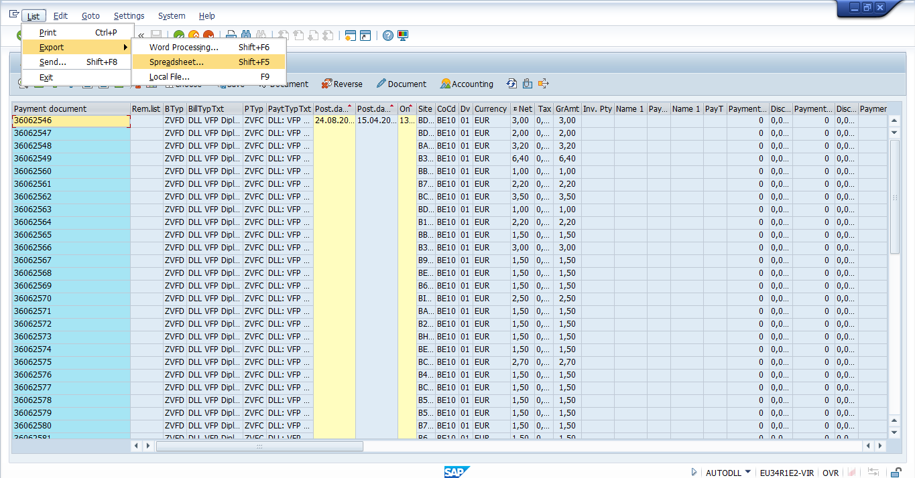

Select from All Available Formats Radio Button and Click on continue.
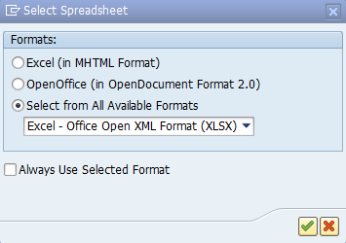
User will get prompt to save the excel sheet.
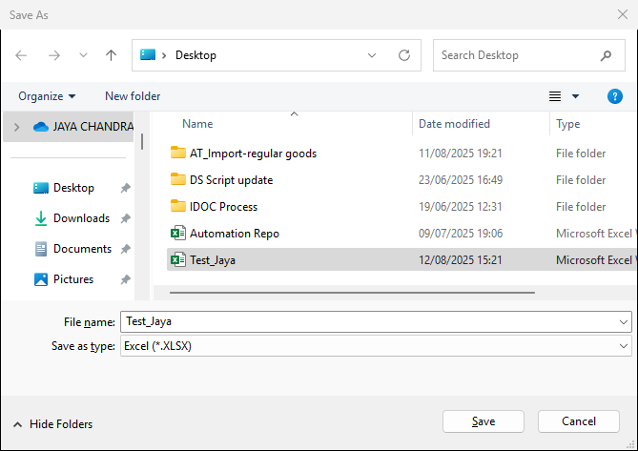
Save the data into excel.
Once the data is exported open the excel and select all the payment document numbers.
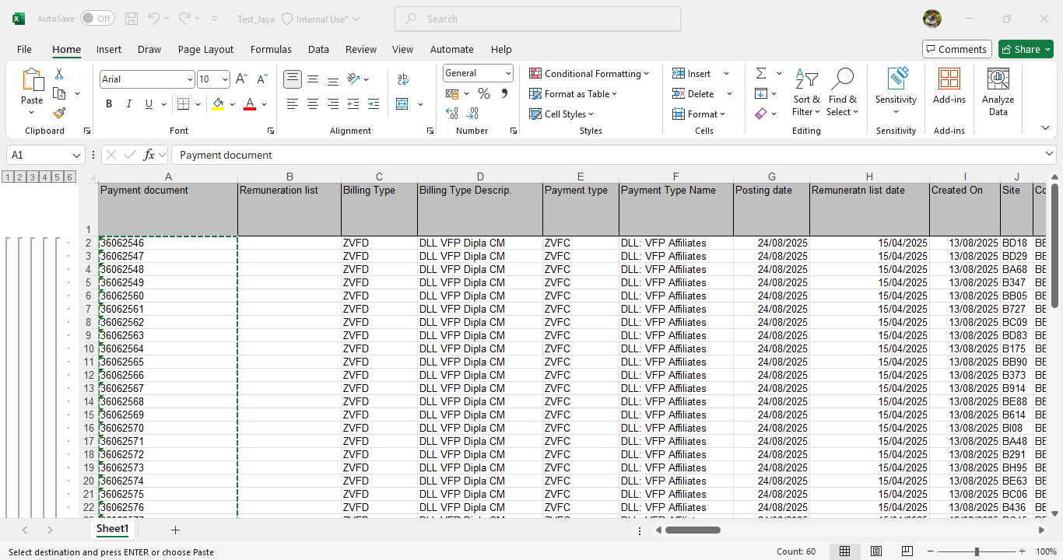

Navigate to T-code WLFF for mass processing of the payment documents.
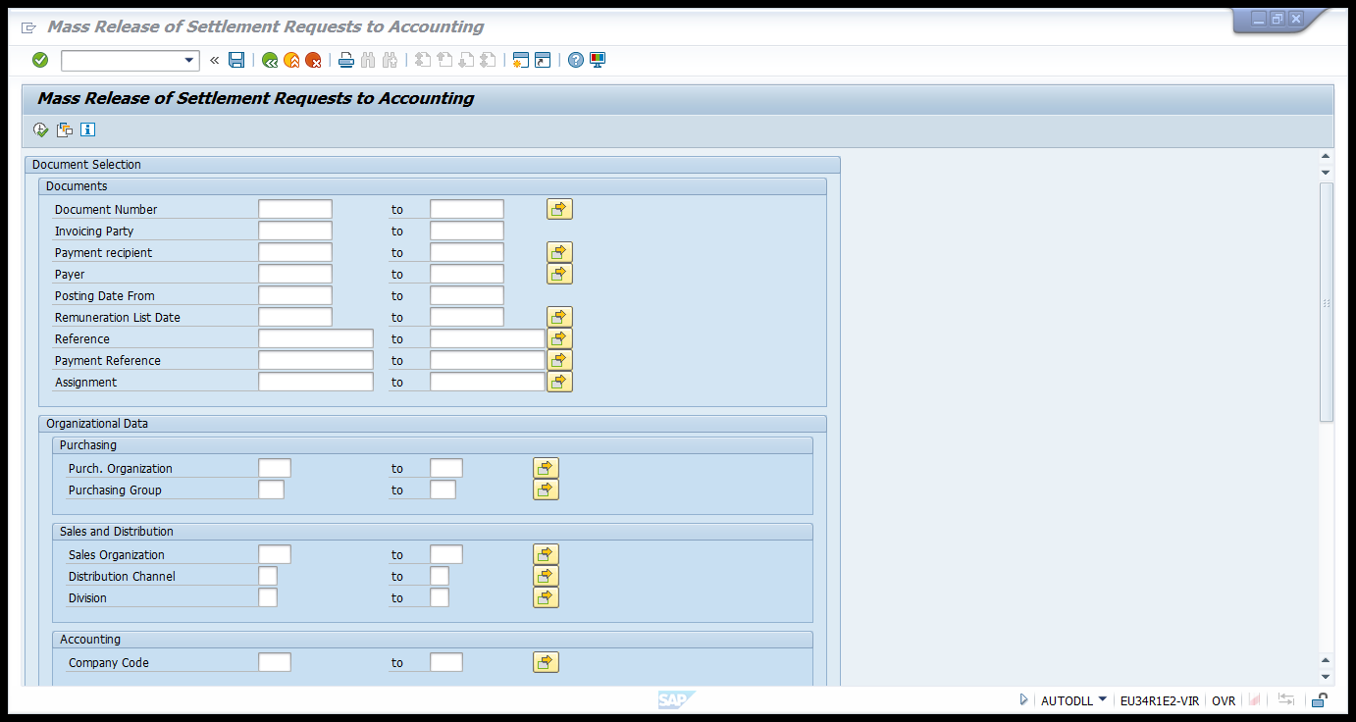

Update the following Fields.
Name of the Run: TEST_AUTO1(It must be different for each run)
Select Multiple selection for Document Number fields.
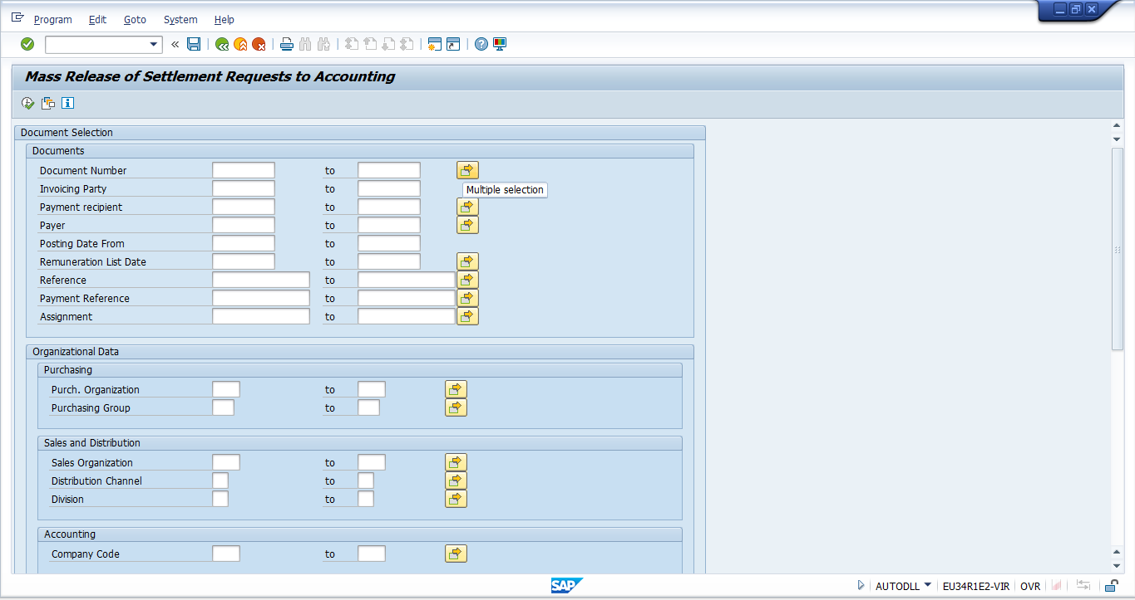
Now paste all the payment documents copied from excel to the fields by Clicking on the Upload from clip board button as shown below.
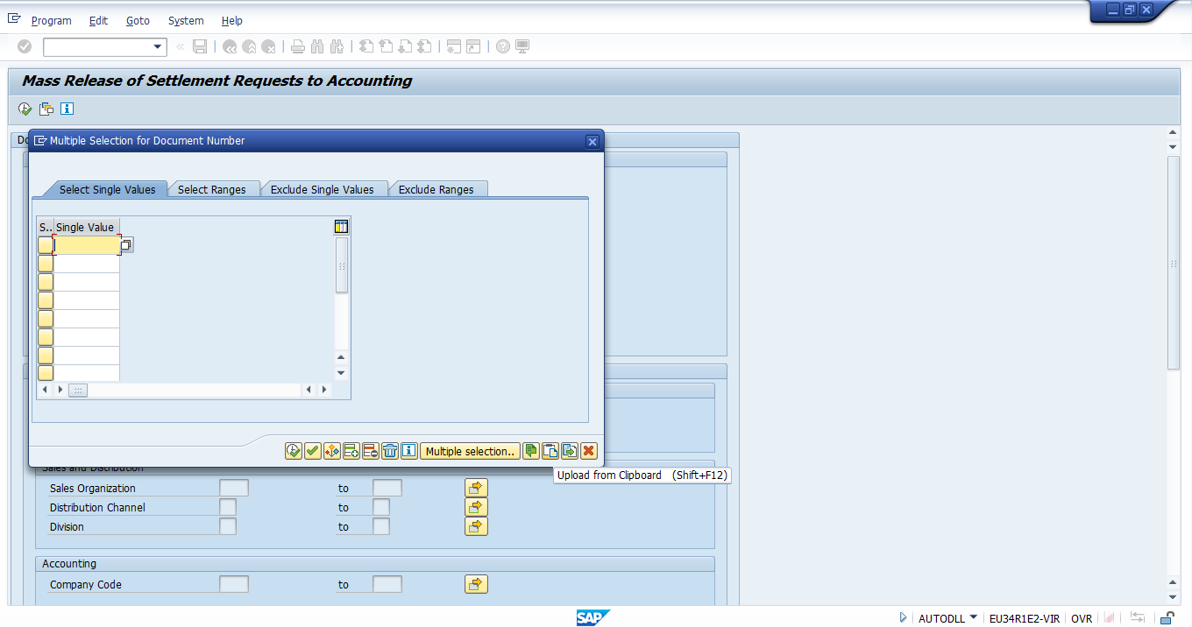

Once done all the data will be pasted to the cells.
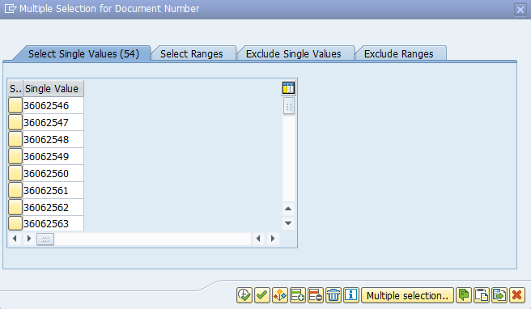
Now click on the Execute button in the popup. Once done navigate to Program Execute in Background.
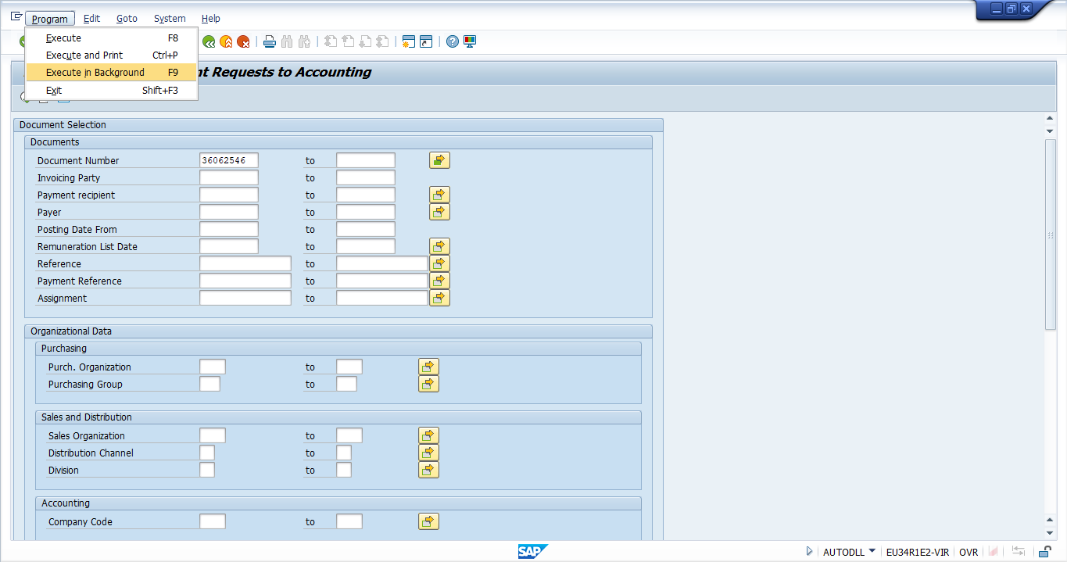

Once Done background Job will be scheduled.
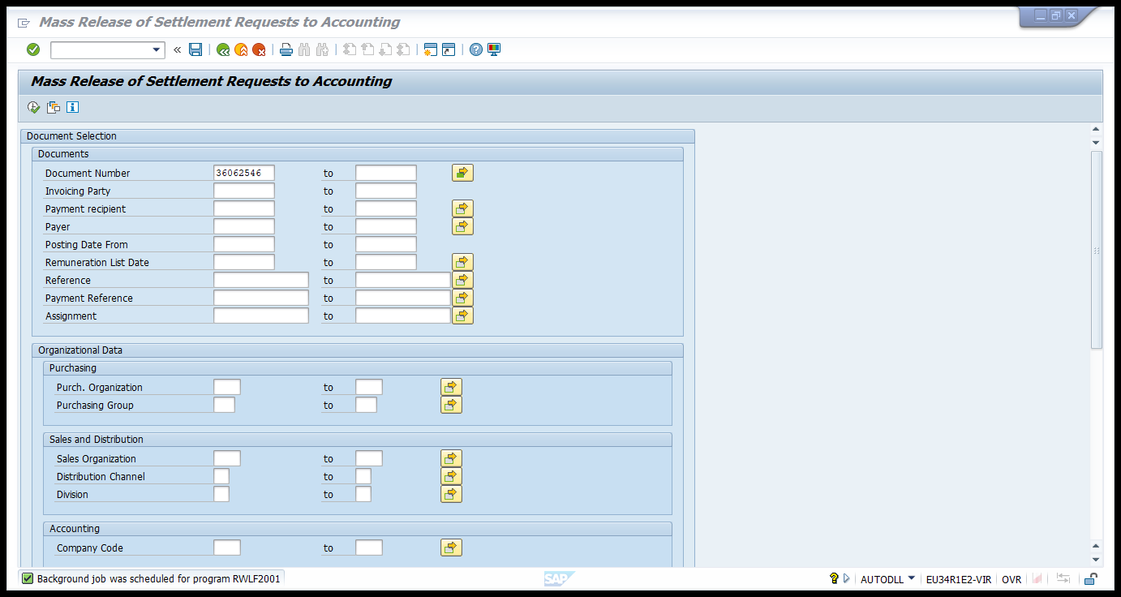
Now all the documents will be processed to Babble Way.
Login to the Babble Way - Babel way
Select the non-invoice goods General.
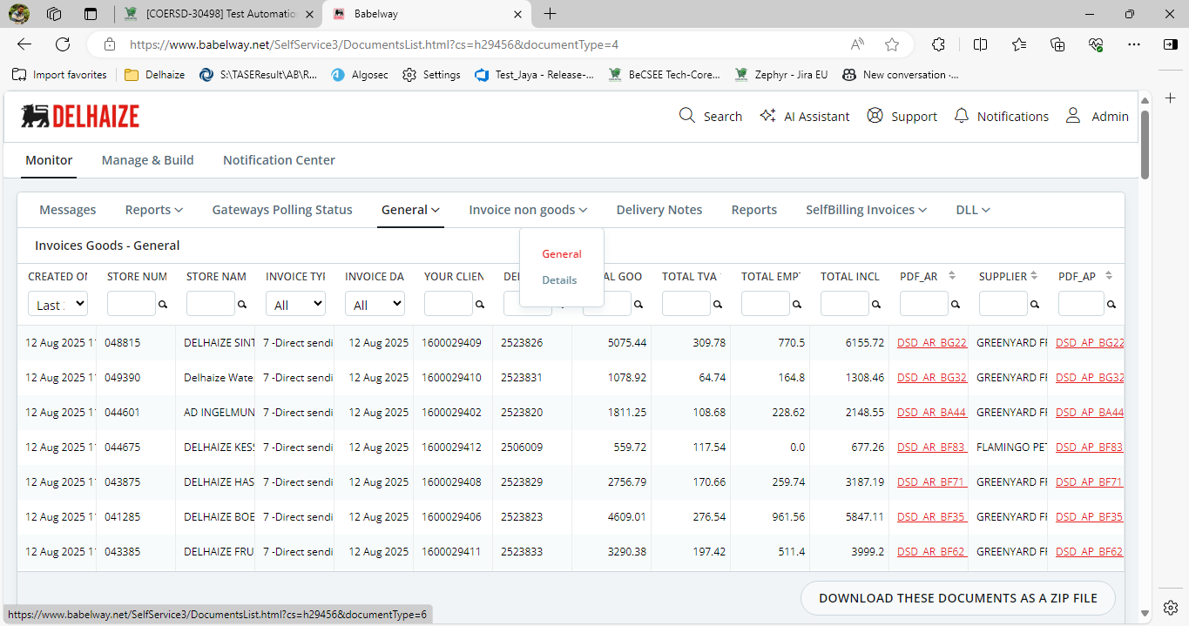

Apply the filters as shown below.
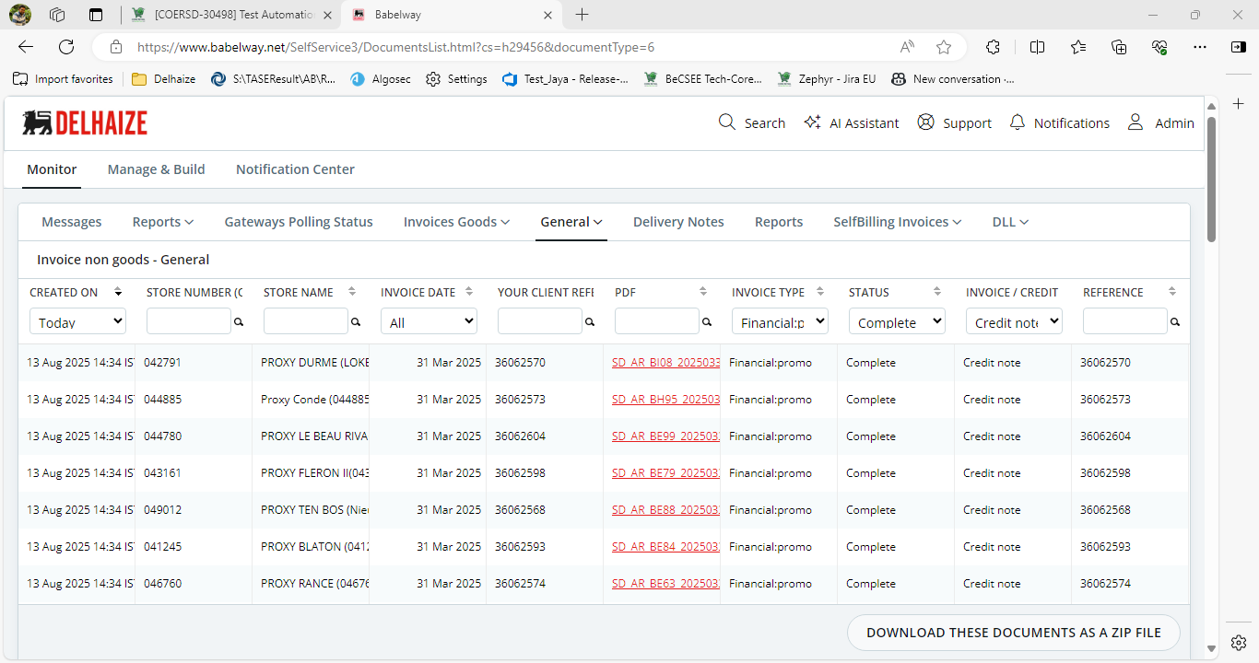
Click on any of the documents and check the net value.
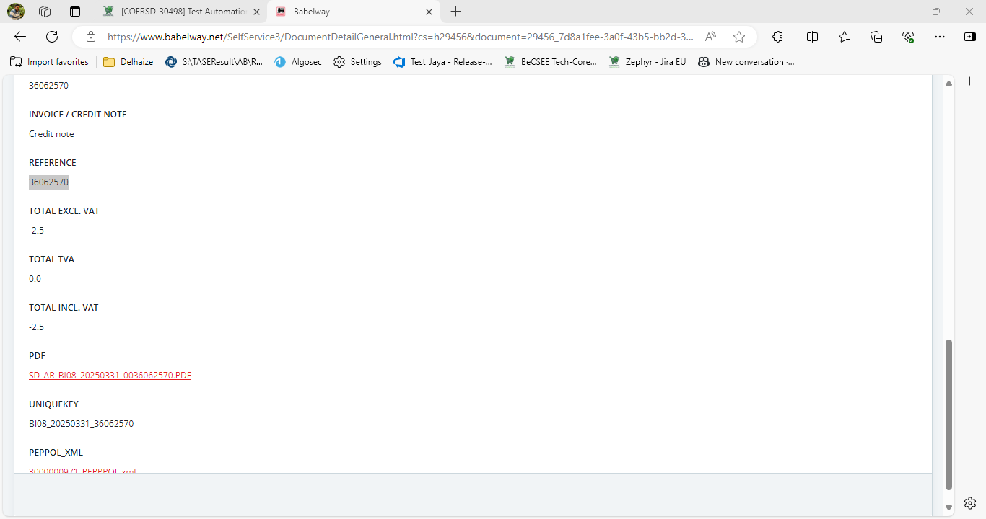

To validate the details displayed in Babble way, Navigate to the WZR3 t-code in SAP ECC
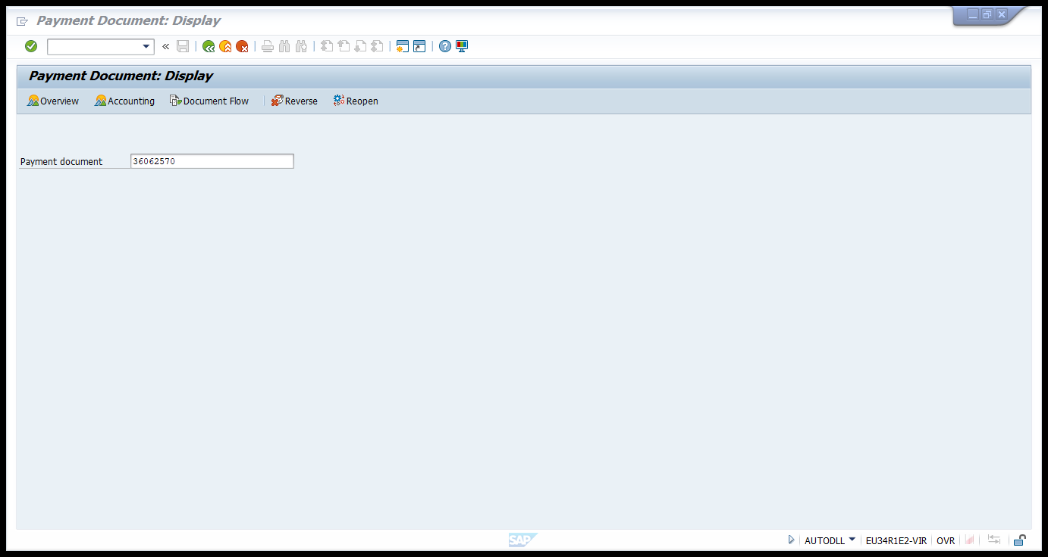
Enter the reference number taken from babble way and press Enter. The net amount details were matching with the Babble way.
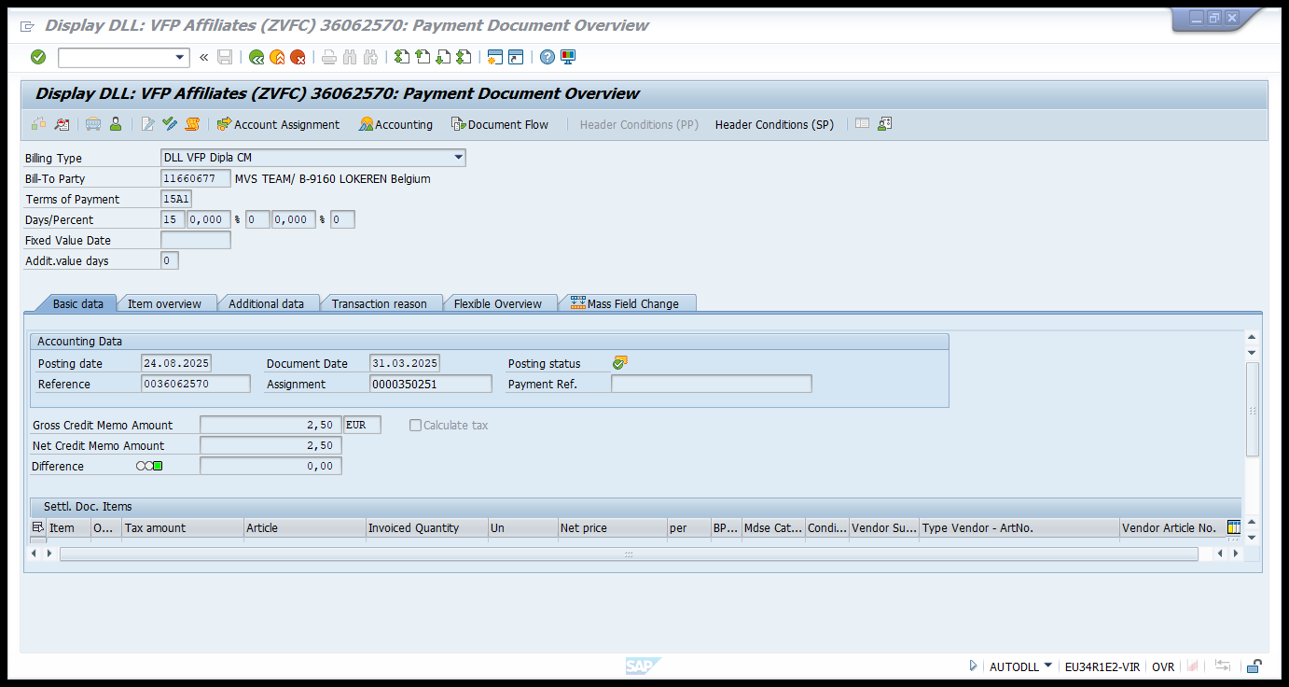

Navigate to Extra Messages Edit.
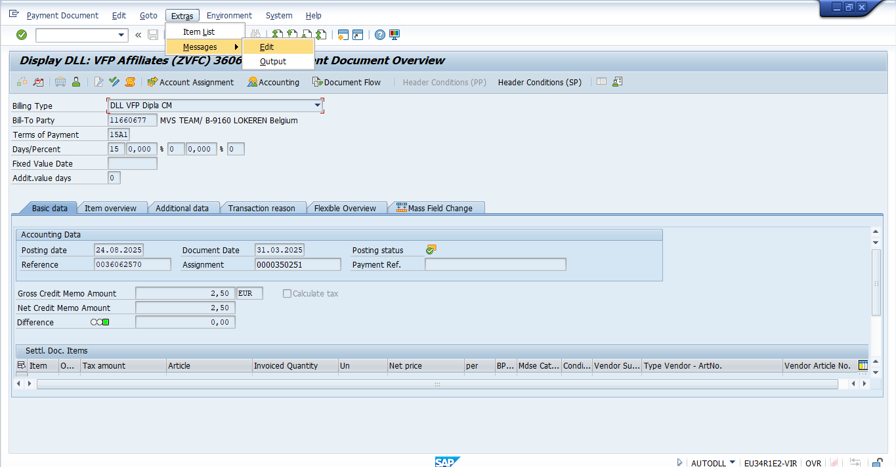
The Output type is Displayed as ZMYF with Green Status (Means the document moved to babble Way)
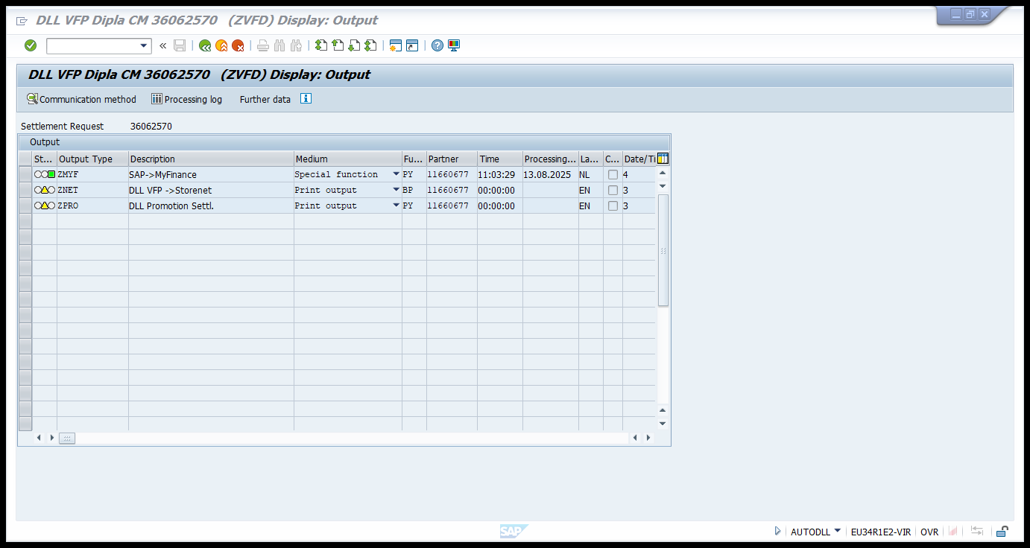

To check the Complete status of the contract run Navigate to the WCOCO.
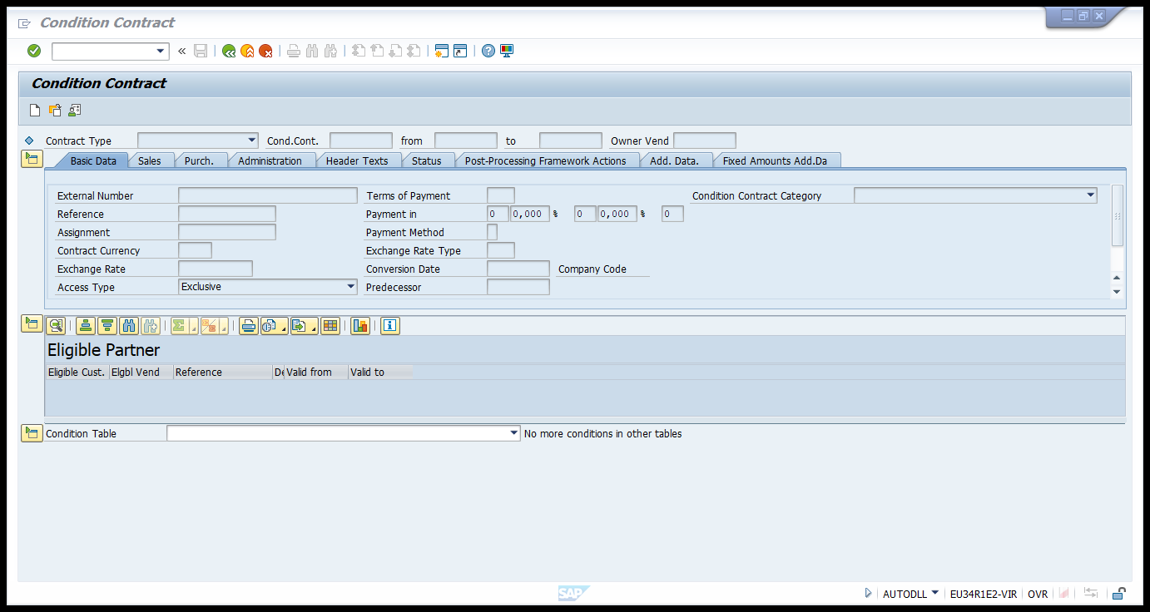
Enter the contract Number.
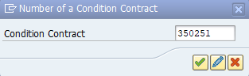

Navigate the Settlement Calendar tab and verify the status of the contract for the calendar month executed.
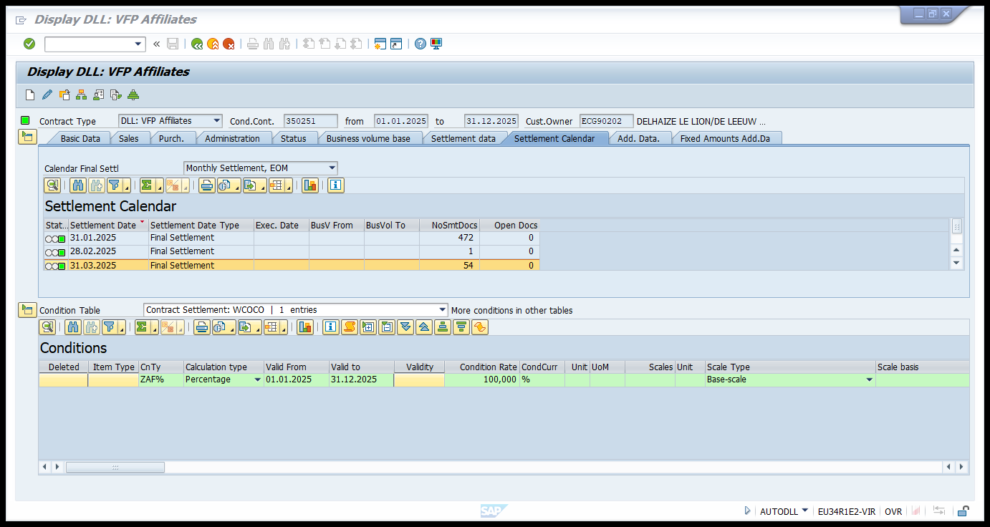

For the month of the 31.03.2025, The status is Green, and the open documents were zero. This means the VFP process executed completely, and the documents were sent to babble way.
Please Note, if the net value of the any Payment document is zero, the data will be shown up in the Babble way (As no Accounting document will be generated for the payment document with net value zero)

